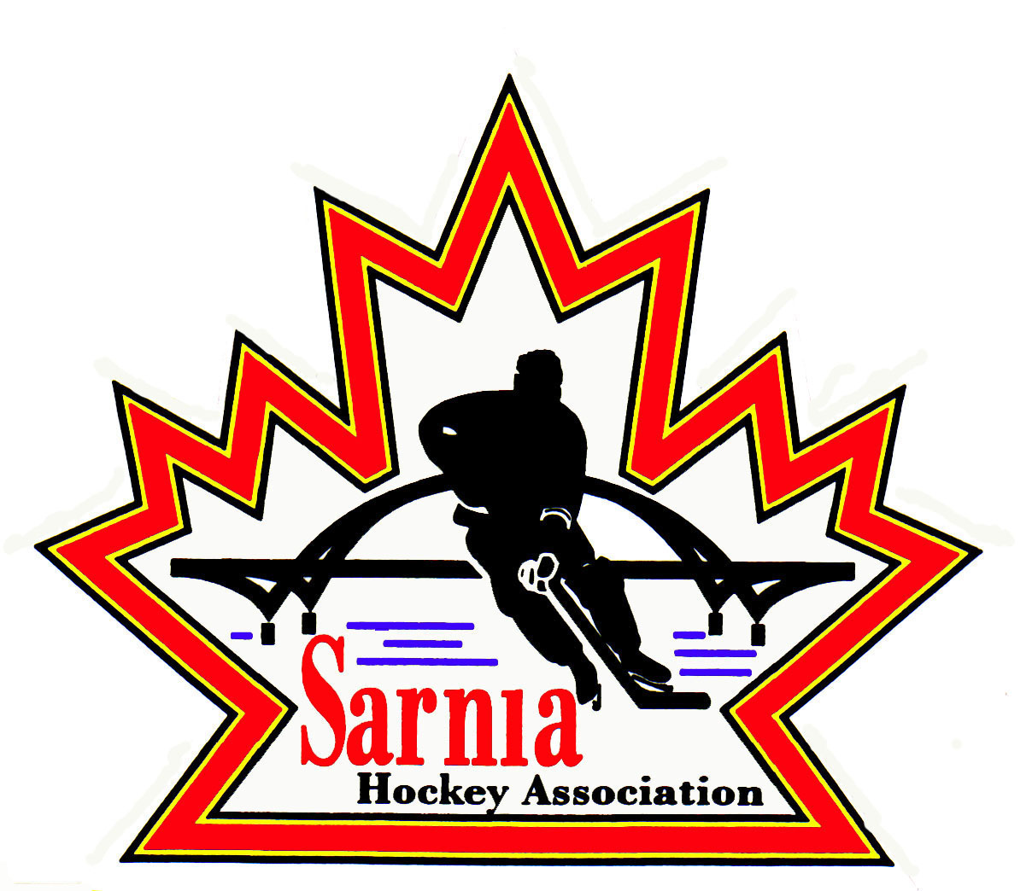

Sarnia Hockey Association

Minutes | Date: SEPTEMBER 3, 2024 | time 7:00 pm

Meeting called by | Paul Walsh, President
Type of meeting | Regular
Secretary | Kelly Lane, Recording Secretary

Welcome | Paul Walsh, President, and meeting Chair welcomed everyone and called the meeting to order at 7:10 pm.

ATTENDANCE | Heather Amaral, Jerry Bernardo, Alister Brown, Emily Brown, Darren Chevalier, Jeff Fogal, Pat Forbes, Dan Hunt, Kelly Lane, Linda Lauzon, Kyle Mellor, John Mellor, David Penner, John Ritchie, Lesley Smith-Taylor, Kevin Taylor, Jason Teather, Barb Walsh, Paul Walsh  Regrets: Andrew Beasley, Jacquie Beasley, Chuck Ewart, Terry Gray, Bonny Marcy, Don McGugan, Jeffrey Needham, Ted Pendle, Wayne Scarrow, Tim Turner

ACCEPTANCE OF MINUTES | MOTION #240903-001  “That the Minutes from August 21, 2024, be accepted as presented.” (J. Mellor/E. Brown)  Carried with amendments as noted.  Conflict of Interest form was mentioned – Rec Vice President to reach out to Select Director regarding this form so that it meets our standards so we can put it on our website. We can then use it in future.

TREASURER’S REPORT | - Financial statement was sent out to SHA board members.  - There was a large adjustment for August of $1,950.00 due to bank statements being only up to date until August 30. There is a lot of revenue due to registration so in order to balance this is a temporary adjustment.  - $5350.00 is sponsorships for U9 T1 and T2 teams. We are holding this money until their bank accounts are set up.  - Active month for payments for registration. Some delinquent accounts where final payment was due September 1. Email to go out to those that have money due. Final payment will be due on Sunday Sept 8.  - Benevity grants coming in and payments are going out to teams.  - Expecting $350,000 for rep assessment fees in next few months. On September 22 we will open the Rep Assessment fee portal for payments on HCR. Treasurer will send out email through HCR with link and instructions to all rep teams.  MOTION #240903-002  “That the Financial report be accepted as presented.” (E. Brown/L. Smith-Taylor)  Carried

BILLS TO BE PAID | MOTION #240903-003  “That the bills be paid as presented.” (E. Brown/K. Mellor)  Carried
  Recipient | Expense | Amount
  City of Sarnia  Mackenzie Industrial  Alliance  Acme Whistles  Jamie Langford  Alister Brown  Lesley Smith-Taylor  Brent Campbell  Emily Brown  Linda Lauzon | Board Room rental for August  Board Room rental (prior)  Final Spring Tryout ice  Rep locks  Game sheets  Logo’d Whistles  Tournament deposit U9 Tier 1(Attached to team loan)  Equipment supplies, hockey sticks, Goalie pads, payment correction from prior submission  Registrar expenses  U18 B/BB tournament loan  Quick book software and Cousi Promo stickers  September Ice Scheduler Honorarium | $ 201.70  $ 201.70  $3,694.82  $ 146.90  $ 250.57  $ 619.02  $ 972.50  $ 421.32  $ 595.28  $4,179.36  $ 264.63  $. 330.00

REGISTRATION DIRECTOR | REGISTRATION REPORT:  MOTION #240903-004  “That 6 spots be taken from U16 and U18 to clear the U21 waitlist.” (L. Smith-Taylor/Bernardo)  Carried  - This would give us 38 players in U21. Almost filled 10 teams in U18-21.  - Some of these players are here for college and some from Point Edward.  - 26 players registered in First Shift.  - We have $9000 in Cousi fund for player assistance. Reached out to Social Service agencies to see if there are any other youngsters wanting to play hockey ideally in U6/7 or U8/9 Divisions where we have the most spots available.  FALL TRYOUT REGISTRATION:  - Tryout registration is open for U8, U9 and U18.  U8 19  U9 36  U18 44  - 2 players from Point Edward for U8/9.  - U18 tryouts start tonight.  PD DAY CAMP:  - PD Day Camp registration will open tomorrow.  ROSTER UPDATE:  - 11 teams that had spring tryouts have rosters submitted.  - 9 are pending, 1 approved, and 1 was rejected.  - 3 teams have not completed requirements.  - Some of these teams have tournaments coming up.
  DIVISION | REGISTRANTS
  Foundations | 152 23 available
  U6 /U7 | 94 26 available
  U8/U9 | 163 71 available
  U11 | 159 5 available
  U13 | 175 21 available
  U15 | 167 3 available
  U16 | 92 3 available
  U18 | 105 10 available
  U21 | 32 6 waitlist
  TOTAL | 1140

ICE DIRECTOR | - All rep games are scheduled. Finished up last BB games last night.  - Ice Scheduler will review and tighten everything up.  - Ice Scheduler will send schedule to Referee Director so referees can be assigned for October 6 start.  - Some teams are putting events in for exhibition games again. A note to be sent out to coaches that Exhibition games need to go to Ice Scheduler so it can go into iDB.  - Some teams emailing for referees – need to go to Ice Scheduler for single point of contact.  - Haven’t finished practices for week 3.

Vice PRESIDENT REP | REP COUCIL MEETING HIGHLIGHTS:  - Some new policies have been released.  - Minor hockey contacts online form has been updated for our Board by our President.  - Video review policy is on the Alliance website. It deals with issues with having cell phones in the dressing room. Cell phones should not be in dressing rooms. Rule of two in dressing room applies so that observers are to ensure cell phones stay in pockets and not out in the dressing room. Issues with Snap Chat photos. Suspensions if this policy is violated.  - Green Arm Band Policy is new for this year. Additional suspensions if there is a maltreatment call against a referee with a green band.  - Overseas travel – there is a special process that you have to follow. Contact SHA President if there are teams planning on doing this. There is a fee and payment for Hockey Canada and one member partner has to attend as well and team would have to pay their way as well.  - Discussion item – consideration of mandating Level 2 trainers. Requirement for Level 1 currently and whether we should bring this up to Level 2. Initial recommendation is for U14 AAA and above. This is more about bleeding injuries and training on this.  - Game Sheet Inc – all the invite codes are supposed to go out this week. Once we receive them, we will put in our Ipads.  - Discussion on 2025 prep skates – push back by some Associations on Spring prep skates due to just being off the ice. It’s a time when ice is in short supply. Alliance will be reaching out to OHF and perhaps getting an exemption.  - Wanted confirmation from Centres for U18 seeded and B/BB on a motion to accept 3 OMHA teams. One team for U15 BB and one team U16 BB and one for U18. Lambeth, St. Thomas and Mount Brydges are the teams, and the motion was passed. These teams are from OMHA. Those 3 teams will come into Alliance and will qualify for Alliance play down tournament.  - U9 Pilot – the OHF is looking at full ice versus half ice. U9 is half ice for half season and then full ice. There have been requests to OHF for the U9 to go full ice from beginning of the season. OHF had put in request to Hockey Canada who rejected it saying not enough data to support the request. OHF picked 14 U9 OMHA teams in tri county area to do full ice and the Alliance U9 Tier 1 teams will be as is. We are the “control”. They will then compare with video analysis. OHF is funding it, and results will come out at the end of the year. Depending on results from pilot study will depend on if they go back to Hockey Canada again with the data.  - It was commented that half ice is likely why our U9 numbers are low – people leaving Hockey Canada because of this and pursuing other options.  - This may change our U9 program for next year.

SELECT HOCKEY | - Update via email  - Coach interviews will take place September 15 not Sept 8.

CLINIC DIRECTOR | - D1 Clinic was completed and 22 attended. 1 cancelled with 75% refund.  - 9 coaches were from Sarnia and remainder from outside centres. We will receive revenue from the 16 outside participants.  - It was a successful course.  - Participants have had their HCR updated.  - Just need the U12A and above to be D1 trained. They need to submit request for Alliance for evaluation.  - Waiting on U12 and U15 A coaches to submit their evaluation request so that their rosters can be submitted.

NEW BUSINESS | POLICIES:  - There are 3 policies that require housekeeping changes on wordage i.e. Chair to President and Vice Chair to Vice President.  MOTION #240903-005  “To replace any mention of Chair or Chairperson with President in Policy 1.04, 1.06 and 1.09.” (K. Taylor/Forbes)  Carried  MOTION #240903-006  “To replace any mention of Vice-Chair with Vice-President in Policy 1.04, 1.06 and 1.09.” (K. Taylor/K. Mellor)  Carried  VOLUNTEER REGISTRATION -SHA BOARD:  - 5 Volunteer registrations are outstanding.  - 7 VSC are outstanding.  - Majority of those outstanding are new Board members or members that never attend meetings.  NEXT MEETING:  - Next meeting is Wednesday, September 18, 2024, at 7:00 pm at Clearwater Arena Lower Hall.

adjournment | MOTION #240903-007  “That the meeting be adjourned.” ( Ritchie)  Carried

Paul Walsh Kelly Lane
President Secretary

